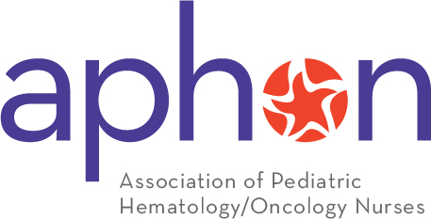
SUBJECT: Proposal to Attend the APHON 48th Annual Conference & Exhibit

Dear Your Supervisor or Employer’s Name,

I would like to attend the 2024 Association of Pediatric Hematology/Oncology Nurses (APHON) 48th Annual Conference, taking place September 11-13, 2024, in Salt Lake City, Utah.

This conference allows pediatric hematology and oncology nurses to learn about new clinical discoveries and how to translate them back into our daily practice. Many of the educational sessions address issues we face daily and teach us how we can implement these improvements to clinical practice to achieve optimal outcomes at our facility. It is also an opportunity for me to network with other pediatric hematology/oncology nurses who face the same challenges we face every day, share experiences, and come away with a renewed sense of energy.

By attending the APHON Annual Conference and Exhibition, I’ll gain access to:
- Earn 12+ NCPD for educational activities in-person, focused on the latest research, treatments and innovations in pediatric hematology and oncology
- Additional NCPD through digital sessions online post-event until December 2nd, 2024
- Professional development support and networking opportunities throughout the event in classroom settings, the exhibit hall and hosted poster events.
- Gain insight on the current healthcare policies and advocacy efforts
- Become inspired, celebrate the achievements and meet the outstanding nurses in our field.

At the conclusion of this conference, I will be able to:
- incorporate or identify strategies essential for managing the challenges facing the patients we serve
- demonstrate increased knowledge to care for diverse pediatric patient populations experiencing hematologic, oncologic, and other related disorders.

Here is an approximate breakdown of costs associated with my attendance:

- Conference registration: $XXX USD
(update as appropriate based on the registration rates current at the time you submit your request.)
- Hotel: Salt Lake Marriott Downtown at City Creek at the negotiated rate of $244 Single/Double – Plus Applicable Taxes. Discounted rates will not be available after August 18, 2024. More information can be found on: https://www.aphon.org/hotel-travel/
- Transportation:
  - Flight: $XXX
  - Roundtrip transportation to/from the airport: $XX
- Meals: Some meals are provided by APHON depending on sessions and symposiums attended. I estimate my cost for meals will be: $XXX
Based on the above breakdown, I expect investment cost for me to attend the APHON Annual Conference will be about: $XXX.

I am prepared to submit a summary report and share trends in best practices and strategies I learned with my colleagues. If you would like to learn more about the Association of Pediatric Hematology/Oncology Nurses’ Annual Conference, please visit https://www.aphon.org/2024-annual-conference/.

Thank you for your consideration and for your support to further my professional development.

Sincerely,

Your Name

